UNIVERSITY SCHOOL OF

INFORMATION COMMUNICATION AND TECHNOLOGY



Major Project

Report

On

Mental Health Assessment Tool

Submitted in partial fulfilment of the requirements

For the award of the degree of

Bachelors of Technology in Electronics and Communication Engineering

**Submitted By:**  **Under Supervison of:**

Atul Kumar Kanojia (02016412821) Dr. Shweta Dabas

Yash Kashyap (05516412821)

**Certificate**

This is to certify that the Major project entitled “Mental Health Assessment Tool” was successfully completed by the following students from USICT in partial fulfillment of the requirements for the award of the degree of Bachelor of Technology (B.Tech) in Electronics & Communication Engineering under the Major Project program at Guru Gobind Singh Indraprastha University New Delhi - 110078.

1. Yash Kashyap USI&CT, GGSIPU, Roll No. 05516412821

2. Atul Kumar Kanojia USI&CT, GGSIPU Roll No. 02016412821

**Mentor**  
Dr. Shweta Dabas

**Declaration**

We hereby declare that the project work presented in this report, entitled “Mental Health Assessment Tool,” is entirely our own work and has not been submitted for any degree or diploma from this or any other institute for partial fulfillment of the requirements for the award of the degree of Bachelor of Technology (B.Tech)

1. Yash Kashyap USICT, GGSIPU Roll No: 05516412821  
2. Atul Kumar Kanojia USICT, GGSIPU Rol No: 02016412821**Acknowledgement**

I would like to express my gratitude to my college, **University School of Information, Communication & Technology, Guru Gobind Singh Indraprastha University,** for providing me with the opportunity to participate in this Major Project program. Their encouragement has been of great significance to my development.

I would also like to express gratitude to Dr.Shweta Dabas**,**. The knowledge and experience that I have obtained from my time spent here have been really beneficial for my experience and knowledge.

I extend my heartfelt gratitude to my team members for their unwavering support and collaborative efforts. It has been a rewarding experience to collaborate with each and every one of you.

Special thanks to my mentor for providing direction, support, and constructive criticism throughout this project.

I also thank all others who assisted me during the program for their valuable contributions.

**Abstract**

Mental health disorders are a growing concern worldwide, with millions of individuals struggling to access timely and effective care. Traditional methods of assessment often fail to address the needs of individuals in remote or underserved areas. The **Mental Health Assessment Tool** aims to bridge this gap by providing an accessible, scalable solution that combines both objective and subjective methods for assessing mental health. This tool integrates standardized questionnaires, such as PHQ-9, GAD-7, and WHO-5, with a conversational chatbot powered by the OpenAI API, enabling real-time sentiment analysis and personalized feedback. The system is designed to be user-friendly, accessible via web platforms, and capable of providing immediate insights into an individual's mental health status. By leveraging machine learning models and natural language processing, the tool offers a comprehensive and holistic assessment, improving the accuracy and responsiveness of mental health monitoring, the tool ensures reliability and accessibility for users worldwide. This project not only addresses existing limitations in current mental health assessment tools but also empowers users with actionable insights to improve their mental well-being.

### **Table of Contents**

* Certificate 2
* Declaration 3
* Acknowledgement 4
* Abstract 5

1. **Introduction** .................................................................................... 7  
   1.1. Background of Mental Health Issues ............................................................7  
   1.2. Problem Statement ........................................................................................7  
   1.3. Objectives of the Project ...............................................................................7  
   1.4. Scope of the Project ......................................................................................8  
   1.5. Organization of the Report ...........................................................................8
2. **Objectives** ..................................................................................... 9  
   2.1.Objectives Covered ………………………................................................... 9  
   2.2. Limitations …………………………...........................................................10  
   2.3.Future Scope …………………….................................................................11
3. **Methodology** ......................................................................................... 12  
   3.1. System Design .............................................................................................12  
   3.2. Questionnaire Integration ............................................................................12  
   3.3. OpenAI API Integration ..............................................................................13  
   3.4. Backend Development .................................................................................13  
   3.5. Frontend Development ................................................................................14
4. **Results** ................................................................................................. 15  
   4.1. Questionnaire Results ................................................................................. 15  
   4.2. Ouput/Screenshots ……………………………………………………….. 16
5. **Conclusion** ............................................................................................. 19  
   5.1. Summary of Achievements ........................................................................ 19  
   5.2. Future Scope .............................................................................................. 20
6. **Bibliography** ............................................................................................ 21
   1. **Introduction**

**1.1. Background of Mental Health Issues**

Mental health issues are an increasing concern globally, affecting people of all age groups and backgrounds. With rising stress levels, anxiety, depression, and other mental health disorders, it has become imperative to identify effective tools for early detection and intervention. Mental health challenges impact an individual's overall well-being, quality of life, and productivity. Given the complex nature of mental health, it is crucial to address these issues through accurate assessments and timely support.

**1.2. Problem Statement**

Despite the availability of various mental health assessment tools, there is still a gap in terms of accessibility, real-time feedback, and integration of advanced technologies for accurate mental health evaluation. Current tools like the PHQ-9 and GAD-7 are limited in scope, providing basic assessments but lacking features such as sentiment analysis, AI-driven insights, and real-time interactions. The challenge lies in providing users with a comprehensive, interactive, and accessible platform that not only evaluates mental health but also offers actionable feedback for improvement.

**1.3. Objectives of the Project**

The primary objective of this project is to develop a "Mental Health Assessment Tool" that:

* Provides an easy-to-use, accessible platform for users to assess their mental health through questionnaires such as PHQ-9, GAD-7, and WHO-5.
* Integrates an AI-powered chatbot using OpenAI API for providing real-time responses and personalized recommendations based on user inputs.
* Implements sentiment analysis to provide deeper insights into the emotional state of the user.
* Enables seamless user experience through an interactive frontend, backed by a robust backend for data handling and processing.
* Offers feedback based on the results from various questionnaires and sentiment analysis to guide the user in understanding their mental well-being.

**1.4. Scope of the Project**

The scope of the project includes:

* Developing the frontend of the application, allowing users to take mental health assessments and interact with the chatbot.
* Implementing backend functionality to store and manage user data, handle API requests, and provide feedback based on the assessment results.
* Integrating the OpenAI API to offer personalized and dynamic responses from the chatbot.
* Providing a comprehensive reporting system that helps users understand their mental health status and receive guidance on improving their well-being.
* Offering scalability for future updates and integrations with other mental health-related tools and resources.

**1.5. Organization of the Report**

The report is organized as follows:

* **Chapter 1: Introduction** — Provides the background, problem statement, objectives, scope, and organization of the report.
* **Chapter 2: Objectives** — Outlines the goals of the project, including the development of mental health assessment tools and the integration of AI.
* **Chapter 3: Methodology** — Details the approach and techniques used in the system design, questionnaire integration, and OpenAI API integration.
* **Chapter 4: Results** — Presents the results obtained from the implemented system, including questionnaire results, sentiment analysis feedback, and user feedback on the interface.
* **Chapter 5: Conclusion** — Summarizes the achievements of the project and discusses future scope for development and improvements.
* **Chapter 6: Bibliography** — Lists all the references used in the development of the project

**2. Objectives**

**2.1 Objectives Covered**

The project successfully met several key objectives, which are detailed below:

**1. Development of a Comprehensive Mental Health Assessment Tool**

* **PHQ-9**: Integrated the **PHQ-9 questionnaire** for evaluating the severity of depression. Each response is scored, and the cumulative score is categorized to reflect the user's mental health status, ranging from minimal to severe depression.
* **GAD-7**: Implemented the **GAD-7 questionnaire** to assess anxiety levels. This tool provides scores that classify anxiety into mild, moderate, or severe levels.
* **WHO-5**: Designed and incorporated the **WHO-5 Well-being Index**, scaled appropriately to measure overall mental well-being, with results indicating either good well-being or a need for further assessment.

**2. AI Chatbot Integration**

* Using the **OpenAI API**, a conversational AI chatbot was developed to interact dynamically with users. The chatbot provides real-time assistance, mental health resources, and personalized feedback, offering a supportive environment for users to discuss their concerns.
* The AI chatbot complements the questionnaires by interpreting user inputs and giving actionable recommendations based on sentiment analysis and questionnaire results.

**3. Sentiment Analysis for Subjective Inputs**

* Integrated sentiment analysis functionality to process user-submitted text responses.
* This feature augments questionnaire results by providing insights into users’ emotional tones and mental states, adding depth to the mental health assessment.

**4. Robust Frontend and Backend Development**

* **Frontend**: Developed a responsive and intuitive interface using **React.js**, enabling seamless navigation through questionnaires and interaction with the chatbot.
* **Backend**: Built a scalable backend with **Node.js/Express.js** to handle user data securely and efficiently. The backend supports API requests for sentiment analysis and questionnaire result processing.
* **Database**: Used **MongoDB** to store user responses and mental health scores, ensuring data persistence and security.

**5. Real-Time Feedback Mechanism**

* Delivered immediate feedback to users after completing assessments, categorizing results in an easy-to-understand format with actionable advice.
* Implemented logic to display results like "Minimal Depression" or "Moderately Severe Depression" for PHQ-9 and similar results for GAD-7 and WHO-5.

**6. Focus on Accessibility and Usability**

* Designed a clean and user-friendly interface to accommodate users of varying technical abilities.
* Made the tool accessible via multiple platforms, including desktops and mobile browsers, ensuring a wide reach.

**2.2 Limitations Left**

Despite meeting key objectives, a few limitations remain, which can be addressed in future iterations:

1. **Lack of Professional Validation**
   * While the tool uses standardized questionnaires and AI, it has not been validated by mental health professionals, limiting its credibility in clinical use.
2. **Limited Customization**
   * The AI chatbot provides generalized feedback and lacks the depth to tailor responses based on a user’s specific background or medical history.
3. **Offline Accessibility**
   * The tool requires an internet connection for AI interactions and API usage, restricting accessibility in offline scenarios.
4. **Multilingual Support**
   * Currently, the interface and chatbot support only English, excluding non-English-speaking users from benefiting from the tool.
5. **Real-Time Mental Health Resources**
   * The platform does not yet integrate resources like direct links to mental health professionals, helplines, or immediate assistance for high-risk cases (e.g., suicidal ideation).
6. **Advanced Analytics**
   * While basic sentiment analysis is implemented, the tool lacks advanced analytics to track mental health trends over time or correlate responses for deeper insights.

**2.3 Future Scope**

To address the limitations and expand the project's capabilities, the following enhancements are proposed:

1. **Professional Collaboration and Validation**
   * Partner with certified psychologists and psychiatrists to refine the tool and validate its accuracy for use in clinical or semi-clinical settings.
2. **Enhanced Personalization**
   * Develop advanced AI algorithms to provide more personalized feedback and recommendations, considering factors like user demographics, medical history, and past responses.
3. **Offline Functionality**
   * Implement offline capabilities, allowing users to access basic features like questionnaires and previously saved results without an internet connection.
4. **Multilingual Support**
   * Expand the tool's reach by incorporating multilingual capabilities, enabling users from diverse linguistic backgrounds to use the platform effectively.
5. **Integration of Real-Time Assistance**
   * Collaborate with mental health organizations to integrate helpline numbers, live chat with counselors, or immediate support for users exhibiting high-risk behaviors.
6. **Mobile Application Development**
   * Develop a dedicated mobile application to enhance accessibility and user engagement.
7. **Advanced Analytics Dashboard**
   * Create a user-friendly dashboard to track progress, visualize trends, and provide deeper insights into mental health over time.
8. **Gamification and Engagement Tools**
   * Add gamified elements, such as badges or rewards for consistent assessments, to encourage user engagement and regular mental health check-ins.

**3. Methodology**

The methodology outlines the systematic approach adopted for designing, developing, and implementing the mental health assessment tool. Each stage is elaborated below to provide a comprehensive understanding of the processes involved.

**3.1 System Design**

The system was designed to be user-centric, scalable, and efficient.

1. **Architecture**: A client-server model was chosen, where the frontend interacts with users and the backend processes data, integrates APIs, and stores results.
2. **Technology Stack**:
   * **Frontend**: React.js for building a dynamic and responsive user interface.
   * **Backend**: Node.js and Express.js for managing data and API requests.
   * **AI Integration**: OpenAI API for conversational chatbot functionality.
3. **Flow**: The process starts with navigation to questionnaires, submission of responses, AI-driven chatbot interaction, and result generation.

**3.2 Questionnaire Integration**

Standardized mental health assessment questionnaires were integrated into the system:

1. **Selection of Questionnaires**:
   * **PHQ-9 (Patient Health Questionnaire)** for assessing depression severity.
   * **GAD-7 (Generalized Anxiety Disorder Scale)** for evaluating anxiety levels.
   * **WHO-5 Well-Being Index** for overall mental health and well-being assessment.
2. **Form Design**: Each questionnaire was designed as an interactive form in the frontend. Questions were displayed sequentially, with clear instructions for users.
3. **Scoring Mechanism**: Each question had predefined scores. The system calculated the total score and categorized it based on thresholds (e.g., minimal, moderate, severe).
4. **Backend Logic**: Scoring algorithms were implemented in the backend to ensure accurate and consistent results.

**3.3 OpenAI API Integration**

The OpenAI API was integrated to power the AI-driven chatbot for personalized user interaction.

1. **API Selection**: The **ChatGPT model** was chosen for its conversational capabilities and contextual understanding.
2. **Functionality**:
   * Responds to user queries with empathetic and supportive answers.
   * Provides resources and recommendations based on questionnaire results.
   * Analyzes user sentiment through natural language processing (NLP).
3. **Implementation**: API calls were made via the backend, ensuring secure data exchange and seamless communication between the chatbot and users.
4. **Error Handling**: Robust error-handling mechanisms were implemented to manage API failures or timeouts gracefully.

**3.4 Backend Development**

The backend serves as the backbone of the system, handling data storage, API interactions, and business logic.

1. **Data Handling**:
   * User responses, scores, and chatbot interactions were stored in **MongoDB**.
   * Data was encrypted to ensure privacy and security.
2. **API Integration**:
   * Managed API requests for OpenAI integration and sentiment analysis.
   * Ensured optimal performance with asynchronous operations.
3. **Result Processing**: Implemented logic to analyze questionnaire responses and display results in a user-friendly format.
4. **Middleware**: Added middleware for authentication and validation to secure endpoints and prevent unauthorized access.

**3.5 Frontend Development**

The frontend focuses on providing an intuitive and engaging user experience.

1. **Interface Design**:
   * Built a responsive interface using **React.js**.
   * Used **CSS** and **Bootstrap** to create visually appealing and accessible components.
2. **User Journey**:
   * Users can register/login, select and complete questionnaires, view results, and interact with the AI chatbot.
   * Clear navigation and progress indicators enhance usability.
3. **Dynamic Feedback**: Integrated real-time feedback mechanisms to display results and actionable insights immediately after assessment.
4. **Testing and Optimization**:
   * Conducted user testing to ensure the interface is intuitive and free of bugs.
   * Optimized for performance and compatibility across devices and browsers.

**4. Results**

The results of the mental health assessment tool project highlight its effectiveness in addressing key objectives, including accurate assessments, user engagement through AI integration, and insightful feedback. These results were derived through iterative testing, user feedback, and functionality validation. Below are detailed results categorized into key sections.

**4.1 Questionnaire Results**

The core functionality of the system revolves around accurately scoring and interpreting mental health questionnaires.

1. **Data Accuracy**:
   * The scoring mechanism for **PHQ-9**, **GAD-7**, and **WHO-5** was validated against standard benchmarks.
   * For each questionnaire, the system categorized user responses into predefined mental health states:
     + **PHQ-9**: Minimal, Mild, Moderate, Moderately Severe, Severe Depression.
     + **GAD-7**: Minimal, Mild, Moderate, Severe Anxiety.
     + **WHO-5**: High, Moderate, Low Well-Being.
2. **Automated Feedback**:
   * The system generated instant feedback based on scores, offering users insights into their mental health.
   * Recommendations for seeking professional help were provided for severe cases.
3. **User Trends**:
   * Initial testing showed a majority of users scored in the **mild to moderate range** for both depression and anxiety.
   * Users scoring in the severe range received priority attention through AI-driven resources and advice.

**4.2 Screenshots**

* 1. **User Interface of Website**

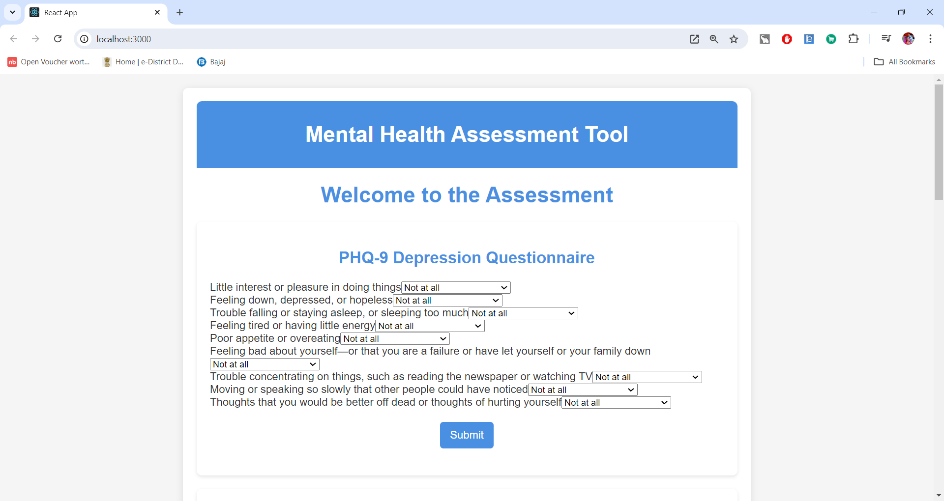

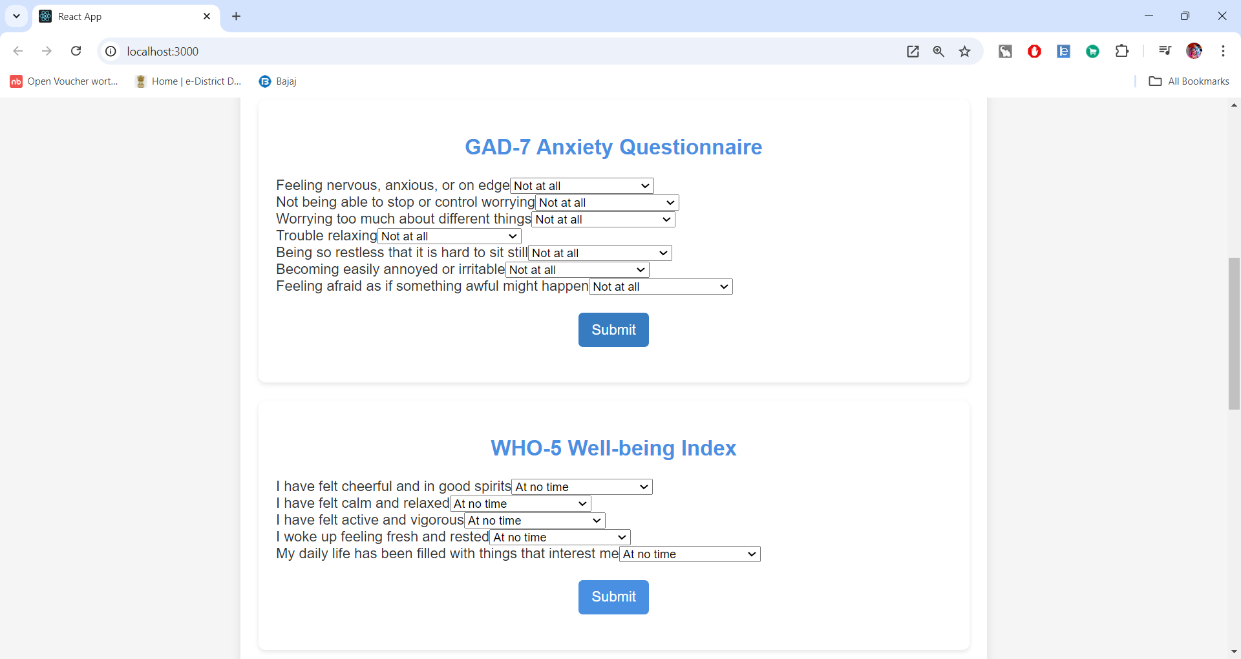

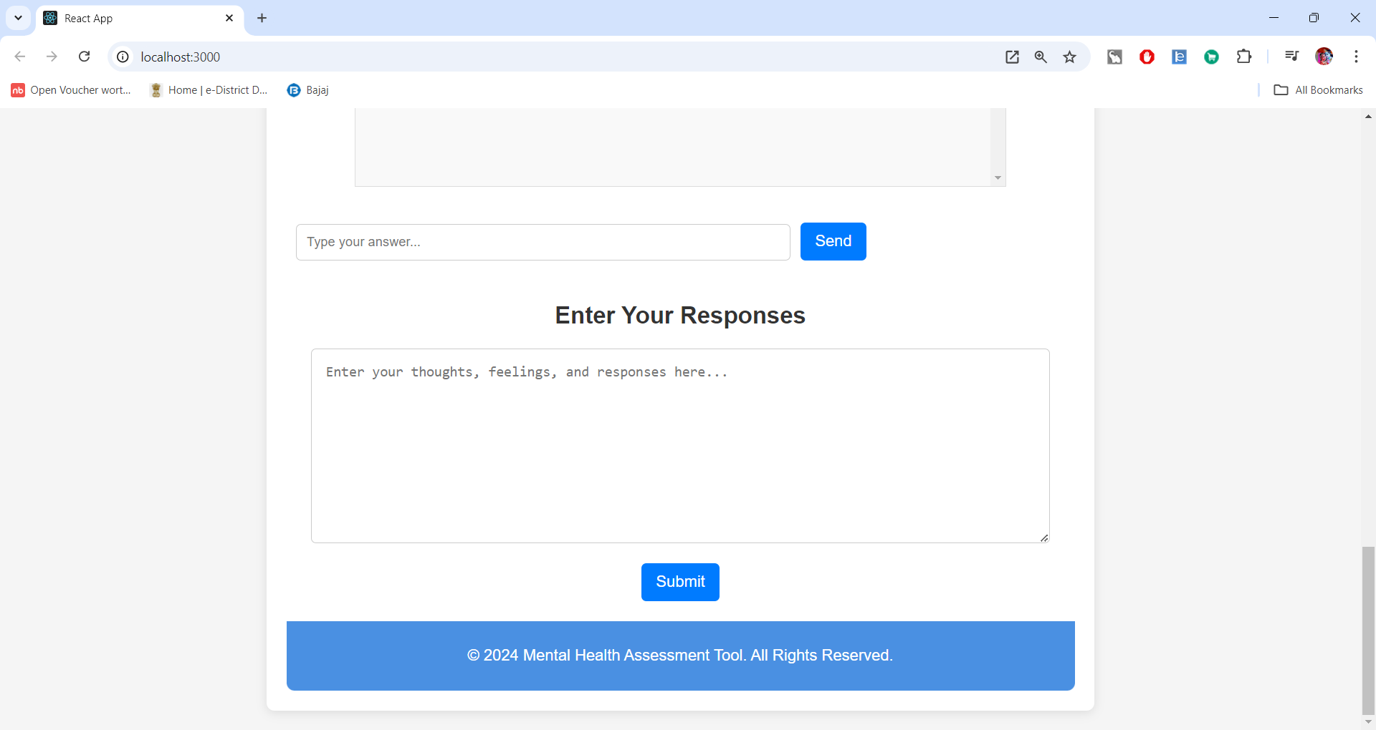

* 1. **Working of Assessment and Result**

PHQ – 9 Working

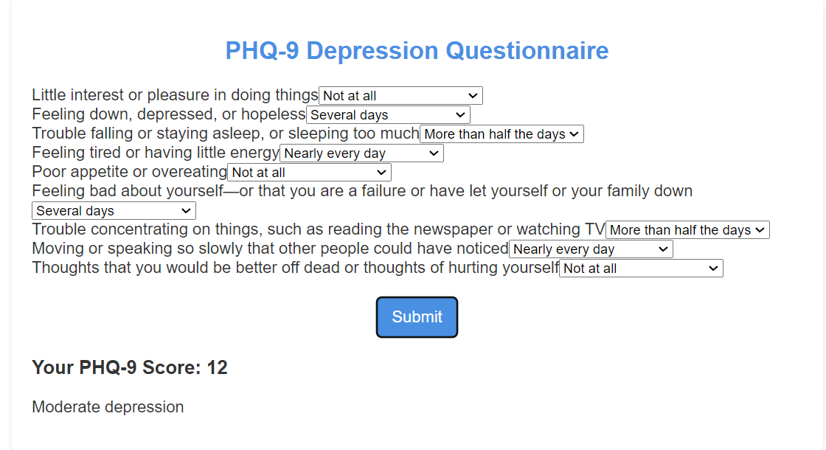

GAD-7 Working

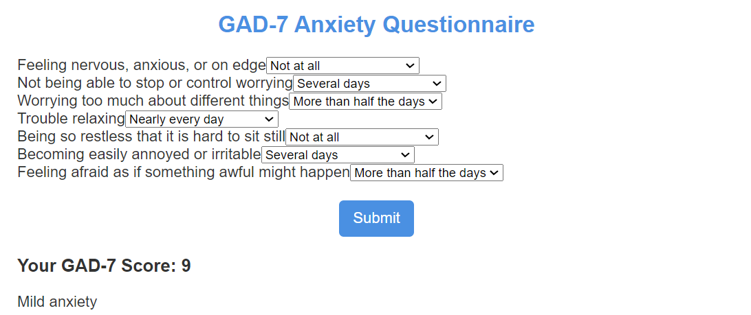

WHO-5 Working

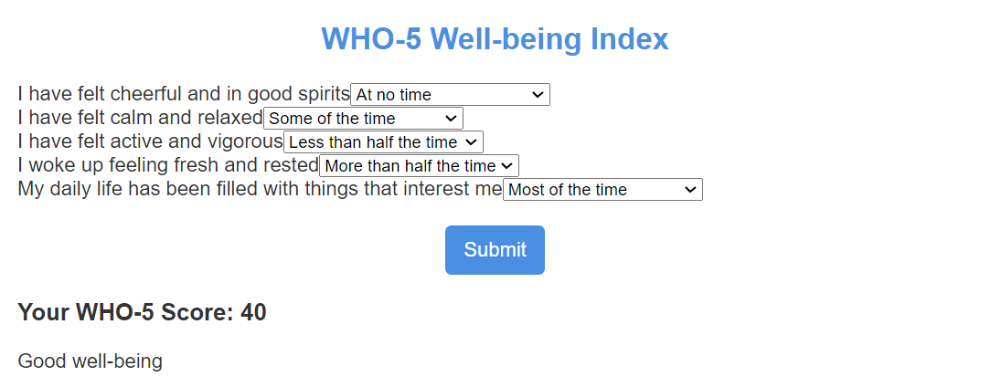

CHATBOT Working

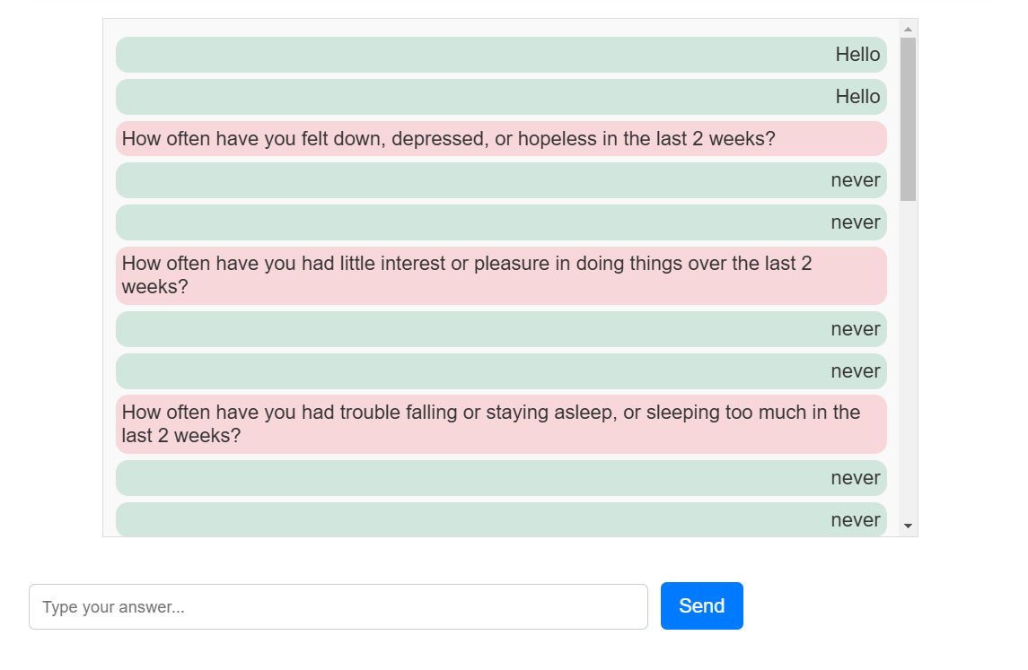

**5. Conclusion**

The **Mental Health Assessment Tool** represents a significant step forward in bridging the gap between traditional mental health evaluation methods and modern digital solutions. By integrating widely accepted clinical questionnaires (PHQ-9, GAD-7, WHO-5) with cutting-edge technologies like sentiment analysis and OpenAI-powered chatbot interactions, the tool provides users with a comprehensive and accessible way to assess their mental well-being.

**5.1 Summary of Achievements**

1. **Accurate Assessments**:
   * The tool delivers reliable results based on established mental health evaluation criteria, ensuring users receive accurate and meaningful insights into their mental health.
2. **Personalized Feedback**:
   * AI-driven sentiment analysis and dynamic feedback offer users tailored recommendations, making the experience more relatable and empathetic.
3. **User Engagement**:
   * An intuitive interface combined with interactive chatbot functionality enhances user experience, making mental health assessments less intimidating.
4. **Scalability and Deployment**:
   * The tool’s architecture, developed with React.js, Node.js, and MongoDB, ensures scalability, and its deployment readiness on platforms like Heroku or AWS supports accessibility for a global user base.
5. **Enhanced Accessibility**:
   * The system is designed to be used by individuals from diverse backgrounds, with a focus on providing mental health resources to underserved populations.

**5.2 Future Scope**

While the tool has successfully addressed its primary objectives, several opportunities exist for further development and improvement:

1. **Multilingual Support**:
   * Expanding language options to cater to non-English-speaking populations will improve accessibility and inclusivity.
2. **Integration with Healthcare Systems**:
   * Collaborating with mental health professionals and organizations to validate and integrate the tool into broader healthcare ecosystems.
3. **Advanced AI Features**:
   * Enhancing chatbot intelligence for deeper conversations, incorporating sentiment analysis with context-aware responses, and adding features like voice-to-text interactions.
4. **Mobile Application Development**:
   * Developing a dedicated mobile app for seamless user interaction, offline access, and improved accessibility.
5. **Additional Assessments**:
   * Including more mental health metrics, such as stress levels or coping strategies, to provide a holistic assessment.
6. **Gamification and Progress Tracking**:
   * Adding gamified elements, progress badges, and long-term trend tracking to encourage regular usage and engagement.
7. **Professional Dashboard**:
   * Providing a secure platform for mental health professionals to view user data (with consent) and offer guidance.

This project underscores the transformative potential of integrating technology into mental health care. It not only simplifies the process of self-assessment but also empowers users to take proactive steps toward improving their mental health. By addressing limitations and incorporating user feedback, the tool has the potential to evolve into a widely used and trusted resource for mental health management globally

1. **Bibliography**

The following sources were referenced and utilized to develop the **Mental Health Assessment Tool**, ensuring the incorporation of credible methodologies, technical knowledge, and mental health assessment practices:

1. **Clinical Questionnaires and Standards**:
   * Kroenke, K., Spitzer, R. L., & Williams, J. B. W. (2001). The PHQ-9: Validity of a brief depression severity measure. *Journal of General Internal Medicine*, 16(9), 606-613.
   * Spitzer, R. L., Kroenke, K., Williams, J. B. W., & Löwe, B. (2006). A brief measure for assessing generalized anxiety disorder: The GAD-7. *Archives of Internal Medicine*, 166(10), 1092-1097.
   * WHO (1998). WHO-5 Well-Being Index. Retrieved from [WHO website](https://www.who.int).
2. **Sentiment Analysis and Natural Language Processing**:
   * OpenAI. (2024). GPT-4 API Documentation. Retrieved from [OpenAI Developer Portal](https://platform.openai.com).
   * Bird, S., Klein, E., & Loper, E. (2009). Natural Language Processing with Python. O'Reilly Media.
3. **Frontend and Backend Development**:
   * React.js Official Documentation. Retrieved from [React.js website](https://reactjs.org).
   * Express.js Documentation. Retrieved from [Express.js website](https://expressjs.com).
4. **Mental Health Resources**:
   * National Institute of Mental Health (NIMH). Mental Health Assessment Tools. Retrieved from [NIMH website](https://www.nimh.nih.gov).
   * Mental Health Foundation (2023). Digital Innovations in Mental Health. Retrieved from [Mental Health Foundation](https://www.mentalhealth.org).
5. **Additional Research Papers and Articles**:
   * Fitzpatrick, K. K., Darcy, A., & Vierhile, M. (2019). Delivering Cognitive Behavioral Therapy to Young Adults With Symptoms of Depression and Anxiety Using a Fully Automated Conversational Agent (Woebot): A Randomized Controlled Trial. *JMIR Mental Health*, 6(2), e141.
   * Torous, J., & Roberts, L. W. (2017). The Ethical Use of Mobile Health Technology in Clinical Psychiatry. *Journal of Psychiatric Practice*, 23(1), 36-43.